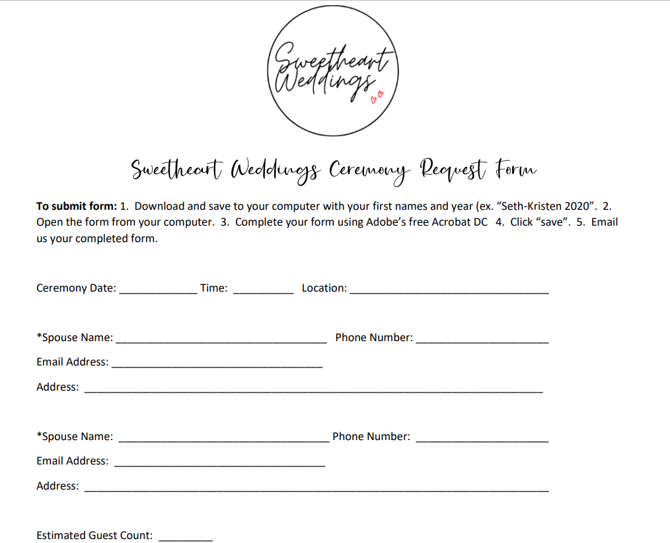

Select Package: | Select Theme: | Select Ceremony (If Applicable):
- Premier | - Colorado Rustic | - Wedding
- Primary | - Loveland Classic | - Vow Renewal
- Simple Elopement | - NOCO Boho | - Family Promise

- A $500 non-refundable deposit is required to book a ceremony date.
- Ceremony balance is due 30 days prior to ceremony date. If the ceremony is canceled less than 60 days before the ceremony date, there will be no refund, and the couple is responsible for the remaining cost of all package/upgrade items ordered and payable by the original wedding date. If canceled more than 60 days before the wedding date, no additional fees apply. If couple has paid in full, a refund may be issued to couple less the deposit amount.
- Package specifics and upgrade services may be modified up to 30 days prior to your ceremony.
- Sweetheart Weddings is not responsible for inclement weather.
I have read and agree to the terms as stated above.

Spouse Signature: ________________________ Spouse Signature: _______________________


970-840-9222
admin@sweetheart-weddings.com
www.sweetheart-weddings.com

